FUNDING YOUR DIOCESAN SOCIAL OUTREACH PROJECT

Be Fundraising Ready: How Caritas can help
- Check your basic project set-up (incl. safeguarding, governance, budgeting, safety, volunteer management) – see here and ask for our Project Set Up Resource
- Look at what sets you apart from other projects to fund (beneficiary engagement, impact measurement, systemic change) - see here and ask for our Project Resilience Resource
- Show how you link into your local community (tuned in with public health, local government, companies, charities; using the social capital of the local community, Asset based community development) – download and use our Community Building Resource here
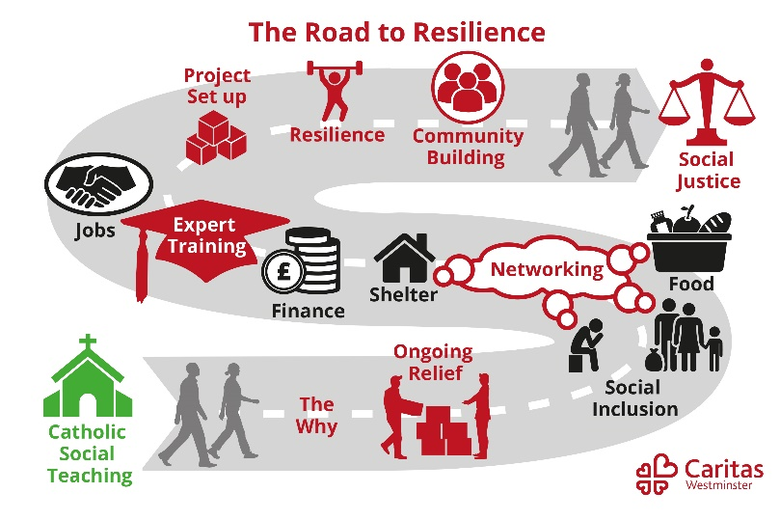
Speak to your Caritas Development Worker for help with any of the above by emailing caritaswestminster@rcdow.org.uk.
All resources are from our Road to Resilience programme

How the Diocesan Fundraising Department can help
The Diocesan Fundraising Team is in place to support parishes and their community projects to raise the funds they need to deliver the Mission of the Church in the Diocese of Westminster.
This includes advice and support on Planned Giving Drives, contactless giving, setting up Stripe and Facebook donate, events, fundraising events, campaigns, hi net worth and corporate donors and grants applications.
Contacts include:
Parish & Digital Fundraising Manager – Laura McLellan – 07568 108 879
Fundraising Officer – Will Wright – 07593 443 491
Trust & Grants Manager – waiting appointment – 07395 798 390

“Fundraising is proclaiming what we believe, in such a way that we offer other people an opportunity to participate with us in our vision and mission.”
“Fundraising is a rich and beautiful activity. It is a confident, joyful and hope-filled expression of ministry.”
Henri Nouwen, Catholic priest, theologian and writer
Ten Top Tips for a fundraising campaign:
- Be ambitious. Be clear, and be positive.
- Set and share the goal – either as a total or in small easy to digest pieces, depending on the audience.
- Create Urgency. Have a time line
- People Give to People – use your social networks, and their social networks
- Tell stories – People respond to causes not things. Eg. if you need funds to buy kennels, talk about the dogs they will house not the kennels you need to buy.
- Try them All. There are many ways of raising funds, generating support and donations of all kinds.
- Use match funding. Offered by some trusts and companies. Also look at the Big Give.
- Share your progress. People are more likely to fund as you reach your goal.
- Keep positive. There will be ups and downs. You will get there.
- Say Thank You

Eight Suggestions from Black Country Foodbank. Thanks to Jen Coleman CEO.
- Collecting Food
Food collections are one of the most straight forward things to organise,
- its physical, easy to understand donation
- there’s no confusion about how its helping someone as there can be with money,
- it a basic need,
- it can be a cheap donation, every can/ packet is important etc
- people understand and empathise
- You can appeal to anyone and everyone, there are no boundaries with who can participate

- Encourage everyone to take part so:
- Produce a collection pack that you can email with basic paperwork, logo, posters ‘COLLECTION POINT HERE’ , shopping lists (3 to a page) top 10 shortages, food and toiletries, a full shopping list (with info of foodbank/story and donation info on the back)
- We don’t provide collection boxes etc because everyone asks for something different but we do encourage people to think of clever ways to collect, mention the Church that used a wheelbarrow during Harvest, take a picture share it, get younger children to take part.

- Be super grateful, encourage and applaud
- send thank you letters, never known before, explain why the donation has been so helpful, you have provided for people in need etc…
- certificates,
- generic thank you cards,
- handwritten, posted, emailed,
- make the effort.

- Tap into your resources
- Relationship with people within your organisation, street collections, small businesses, community groups,
- volunteers often volunteer for other organisations.
- Churches, so easy to start a collection point
- Use the Caritas Community Building Workbook

- Share the love
- Partner Projects and surplus, increase the available food provision, through other ways, hot meals etc – beans!

- Use all the resources on your doorstep/in your community
- Schools – such a valuable resource, ask them what you can do for them? Would they like a few emergency parcels?
- Offer assemblies if you have the resources
- Offer to show the school council around, ask them to bring questions, always such a winner and so funny, not necessarily while foodbank is running but they love to know what is in a parcel, how many people are fed, how much everything weighs
- As an example, we contacted Kate Milner about her book ‘It’s a no money day’, and received them half price. funding available for a project like that, provide resources if you can but the book as a gift opens relationship
- Businesses often like to support because of their CSR, holding a collection is a great way to build team, support local community and often leads to the conversation about the need for financial donations. Food can often lead to finance! Small businesses understand the pressures of finance which can be similar to running a charity, there is space for honesty about costs. They are often keen to support with a raffle/ sponsored event, such as a cycle, run and sometimes want to have a ‘charity of the year’ where they hold numerous events to raise funds. If they want a photo and a bit in the newspaper then say yes!
- Businesses also enjoy volunteering and even if this is only for a few hours sorting through donations it can be so valuable in building relationship.
- Community Groups – Scouts/Guides/Girls Brigade/youth groups

- Keep Foodbank in people’s minds
- Social media, free and easy to use, don’t make it too complicated, read the audience
- Mailchimp (free! And easy to set up) or some sort of email
- Church - speak at the front, make sure there is a permanent collection point, empower someone to take control of it
- Be in meetings, be present,
- Remind people of the need
- Talk to the local newspaper, take photos
- Launch campaigns, mention our 80 can Lent Campaign, Harvest, the books, summer holidays, breakfast push
- Tell stories – remind people about why a food parcel has such an impact on people, life stories
- Invite your local councillor, public health contacts, CAB, etc.

- Final thoughts:
- Not everyone can donate food and toiletries due to issues with mobility, elderly etc, we tell everyone that if you want to donate finances specifically for food and toiletries then we will restrict the funds for just that and buy the items we need when we need them, people are very happy with that option

