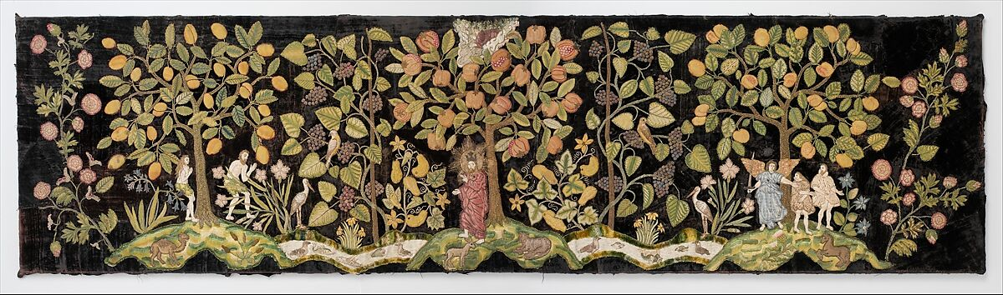

Irwin Untermyer
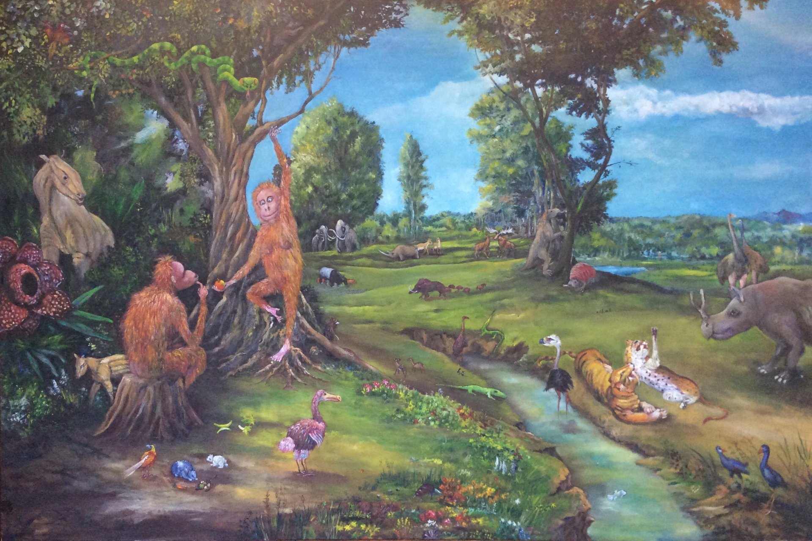

Adam and Eve in The Garden of Eden
By MarkPenderArt

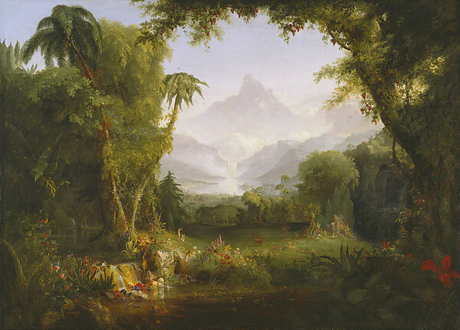
Title: The Garden of Eden
Artist: Thomas Cole

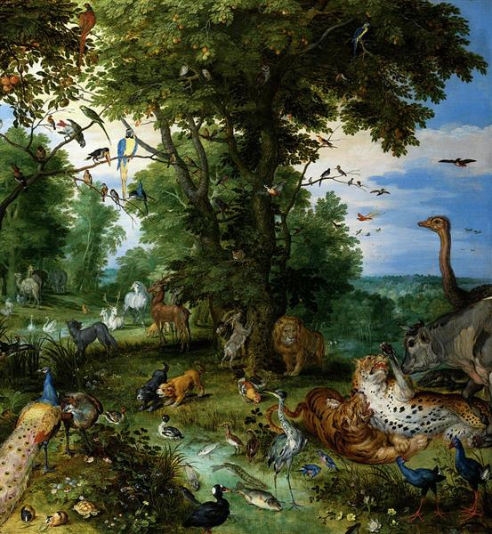

The Garden of Eden
Jan Brueghel the Elder
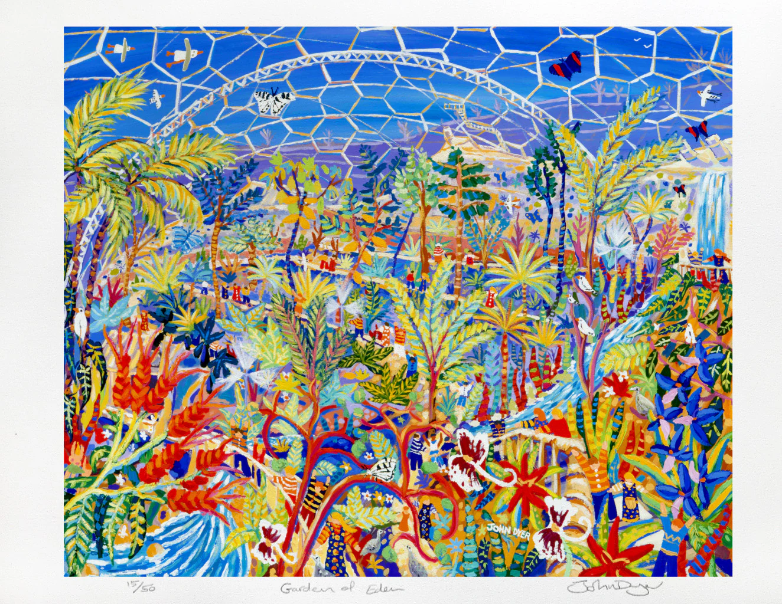

'Garden of Eden'. Limited Edition Print by The Eden Project's artist in Residence John Dyer of the Rainforest Biome.

