# ImageDebate Perspective 1: International Climate Leader

Debate Perspective 2: Head of renewable energy company

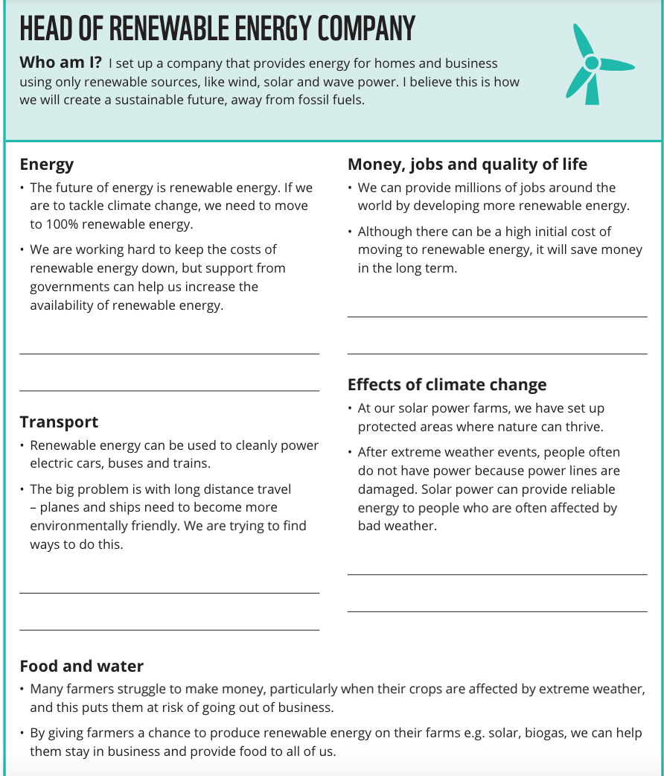

Debate Perspective 3: Person affected by extreme weather

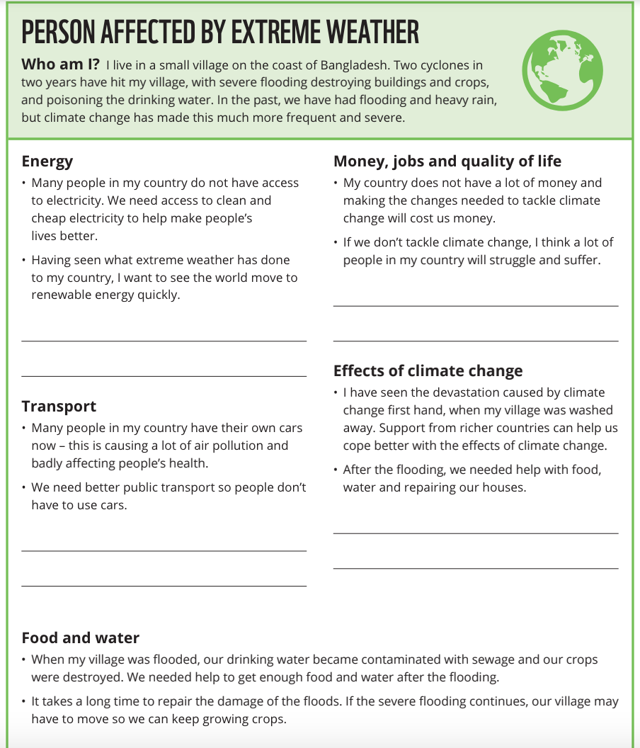

Debate Perspective 4: Head of an oil and gas company

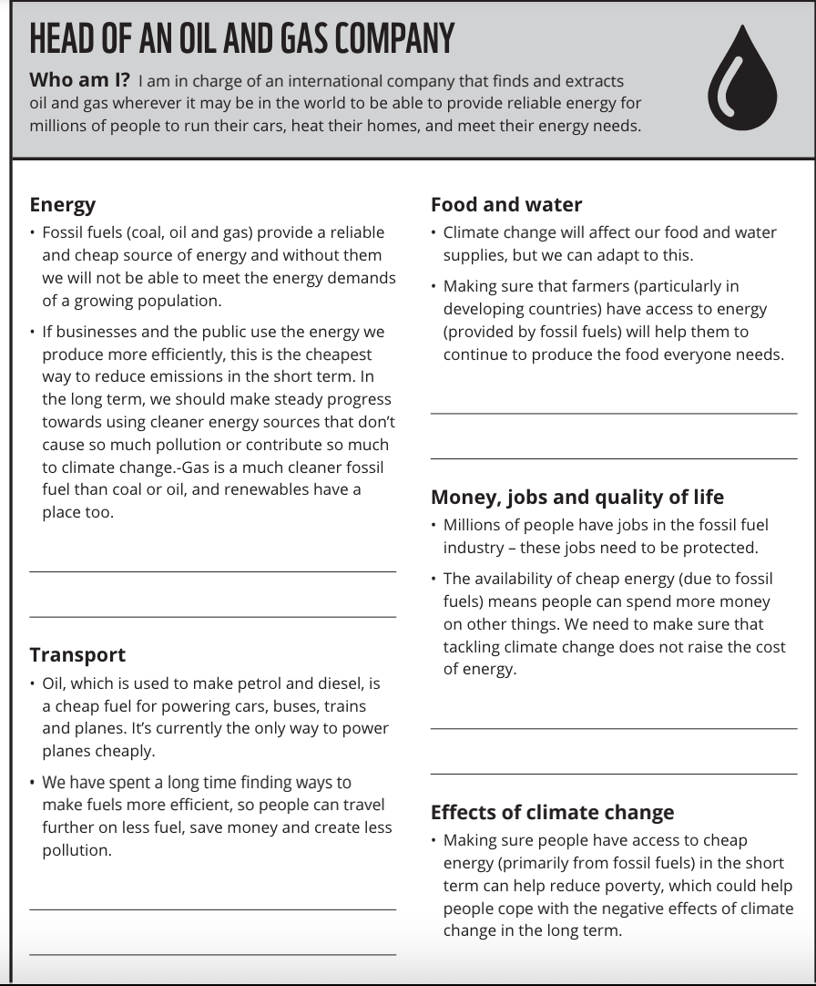

Debate Perspective 5: UK Prime Minister

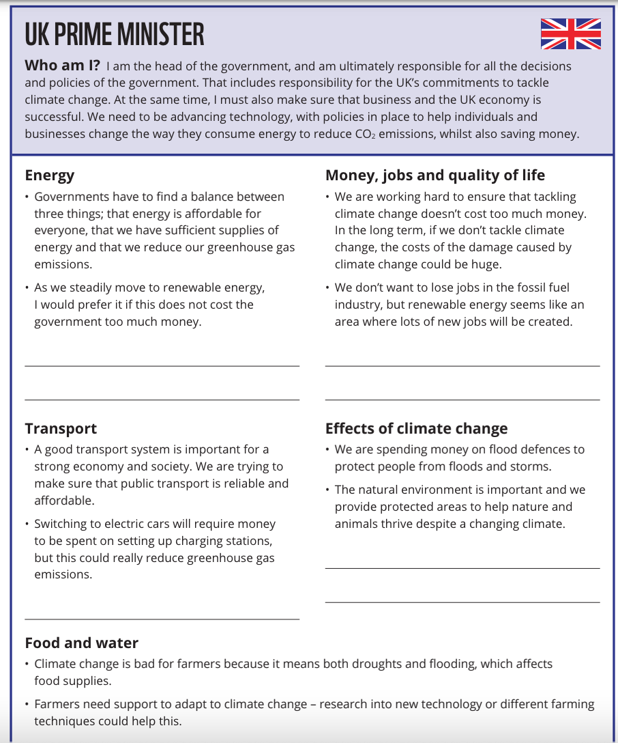

Debate Perspective 6: Head of a large international company

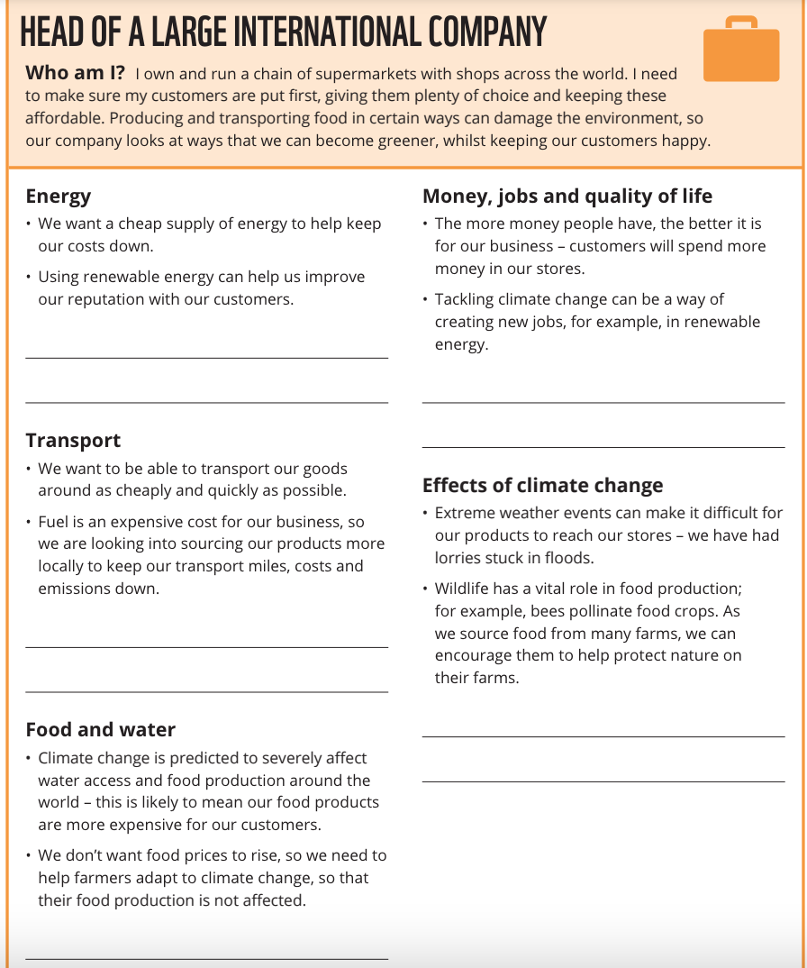

Debate Perspective 7: Green school ambassador

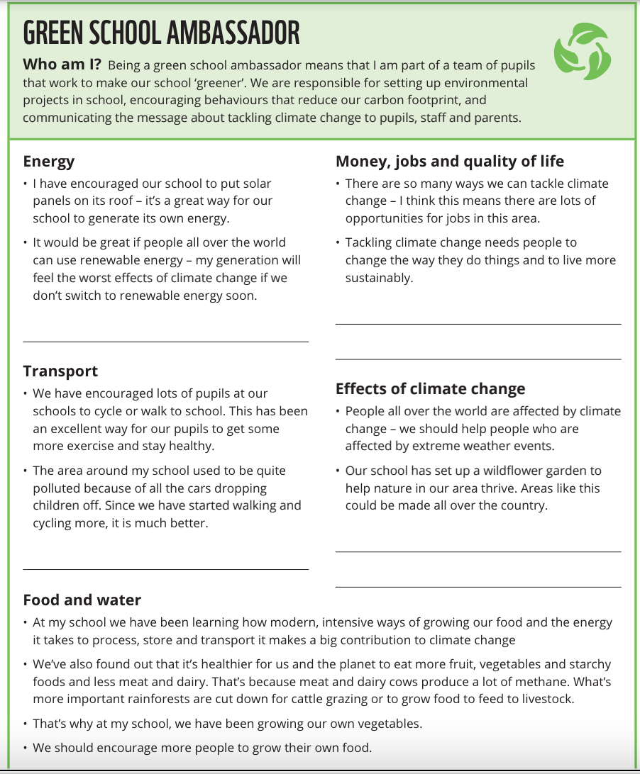

Debate Perspective 8: Climate scientist

