Corrymeela: The Site/Location

#### **The Corrymeela Site**

The original main building, known as “The House,” lasted until 1997 when it was replaced by the current building. Over the years, multiple buildings were added to the site as the needs of the community developed and changed. The most recent addition to the infrastructure of the Ballycastle site is the Davey Village—a residential and conference unit whose name pays tribute to Corrymeela’s founder. The site can currently cater for 100 people residentially and frequently hosts multiple groups who join in the life of Corrymeela during the course of their stay.

There is something spectacular about the site— it is, in a certain way, a theology of place. We are blessed with such a place to do our work— with views to Kenbane, Fair Head, Rathlin Island and the Mull of Kintyre coming down like a ribbon of Scotland in the distance. It is a gathering place where the islands of Britain and Ireland are in close view of each other, about 15 miles across at the closest point. Whether it is cloudy or clear, sunny or stormy, the site offers an immediacy to the elements. To be at Corrymeela is to be close to the natural world, and in being close to the world, we believe that we can become close to each other’s stories— spoken and unspoken. 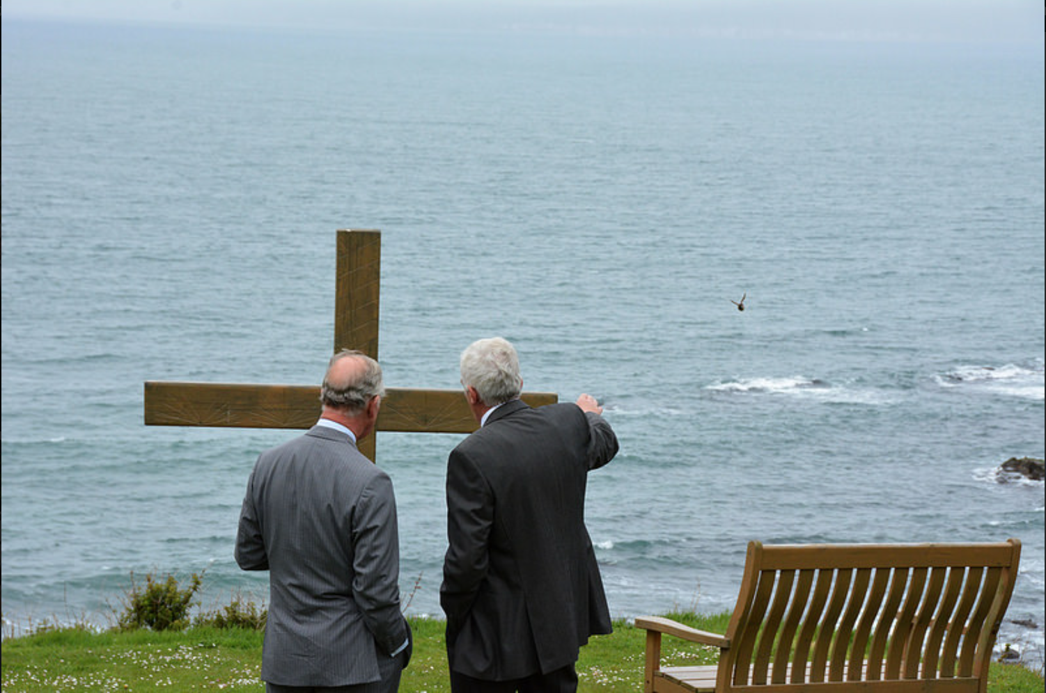

#### **Holy Places – The Croí**

On the site we have a space of worship called The Croí, which is designed in the shape of the human heart. “Croí” is the Irish word for “heart.”

This place is rightly called An Croí – the heart. Indeed it is heart–shaped. Here we can take time to listen to the great heartbeat – in a society where there are so many violent and destructive beats, here we can take time to listen to the Heartbeat that guides, inspires and unites us all together.

Ray Davey

The Croí is an open place. It is not for any particular group or tradition but for all. It is for those who try to follow Christ and those who have not reached that stage, but want to be here.

It is a place of reflection and challenge, where Bonheoffer’s question is often asked: “What does it mean to follow Christ today?”

It is a place of celebration and hope. There are times of laughter and joy with songs and music and drama, proclaiming the unity of God’s creation and the totality of life together. Sometimes it is a place of sadness and tears, where the bereaved and broken find hope and strength.